Concise Notes:

* Is an element of O θ Ω
  + ∈ *O()*
    - Think of as <=
  + ∈ θ *()*
    - Think of as =
  + ∈ Ω ()
    - Think of as >=
* IMPORTANT FORMULAS!!!
  + Text

    Description automatically generatedText

    Description automatically generated

Problems:

* 11) Sum from i = 0 to n – 1: (i^2 + 2)^2
  + (i^2 + 2)^2 = i^4 + 4i^2 + 4

* 12)
  + 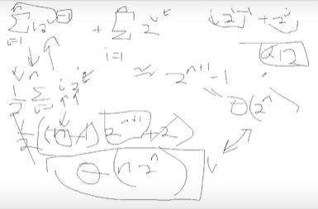
* 13)
  + if(not connected)
    - Return none
  + If(not simple graph)
    - Return none
  + If(number of vertices < 3)
    - Return none
  + If(every vertex has 2 edges)
    - Return ring
  + If(every vertex has number of vertices – 1 edges)
    - Return mesh
  + If(1 vertex has number of vertices – 1 edges && all other vertices have one edge)
    - Return star
  + Return none
* 14)

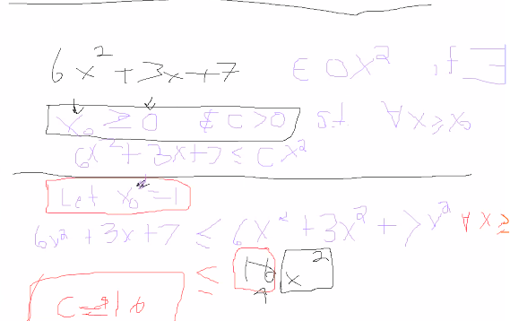

* 15)

* 16)

Questions:

* Summation moving n in front
* How to solve for big theta if big o and big omega